Instruction for software
Step1：Connect the laser to computer with RS232 connection (the line is plug with nine apertures, 2 feet is TXD, 3 feet is RXD, 5 feet is GND). Turn on the laser, start the software “AO-S”. (See below picture for reference)
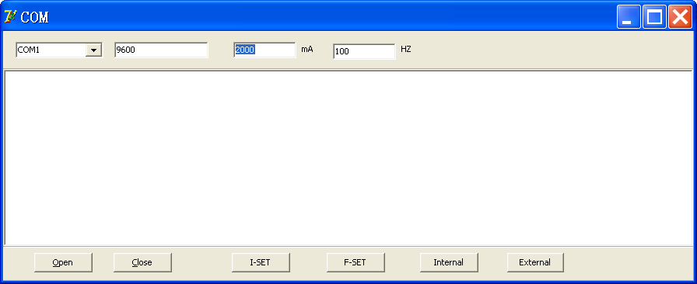
Step2：Right click “Computer” and select “Manage”.
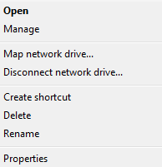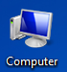
Step3：Run the Device Manager to confirm the Ports information, like the one shown in the figure, it’s COM4. There may be other USB Serial Ports, please confirm which one is the correct Port connected with the laser.
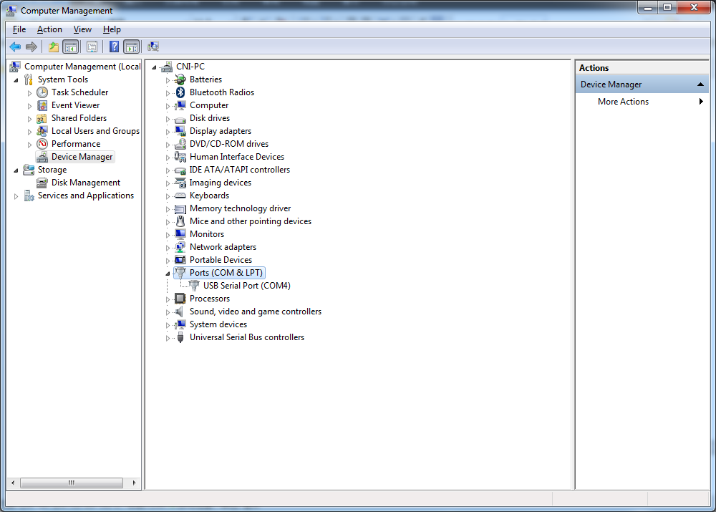

Step4：Click“Open”.
Step 5：Set current(Such as ：2000)
Step 6：Click“I-SET”, the laser will work under current of 2000mA.
Note：Input current range (0~10400mA).
Step 7：Set frequency(Such as 1000)
Step 8：Click“F-SET”, the laser will work under frequency of 1000HZ.
Note：Input current range (1Hz~50kHz).
Step 9：Click“Internal”，the laser will work under the mode of internal.
Step 10：Click“External”，the laser will work under the mode of external.
Step 11：After operating, click Close to close the software.
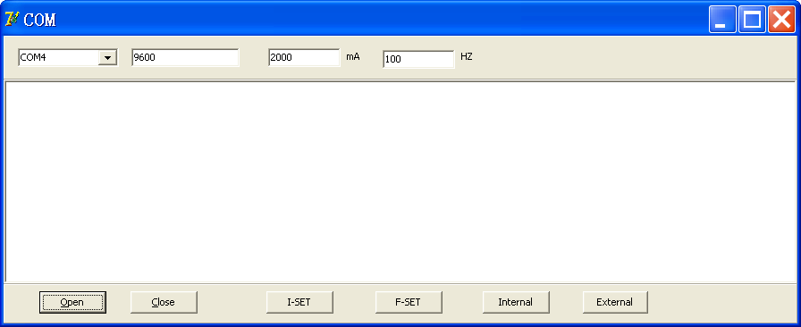
Step 6
Step 8
Step7
Step 11
Step 4
Step 9
Step 10
Step5

